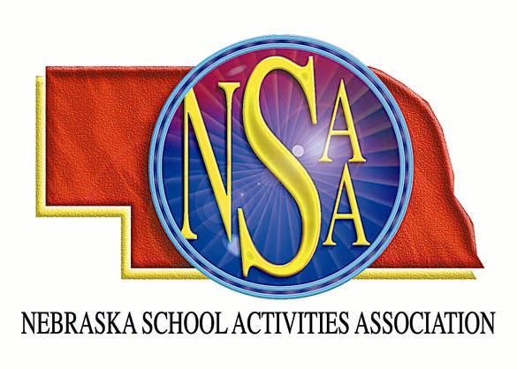

The NSAA is asking for your help with the 2006 State Volleyball Championship. The 2006 State Volleyball Championship will be held in Lincoln, November 10 and 11.

REGISTERED NSAA VOLLEYBALL OFFICIALS WILL BE GIVEN PREFERENCE IN ASSIGNMENTS

Yes, I am a registered NSAA Volleyball Official

I am interested in working as a/an:

Announcer – Please indicate the number of volleyball matches you have announced this
season.

Scorekeeper – Please indicate the number of volleyball matches you have served as a
scorekeeper this season.

Score Clock – Please indicate the number of volleyball matches you have served as score
clock operator this season. __

Libero Tracker – Please indicate the number of volleyball matches you have served as libero
tracker this season.

Line Judge – Please indicate the number of volleyball matches you have served as a line
judge this season.

Ball Shagger

Supervisor of Workers

Friday Sites: Pershing Auditorium (Classes A & D1), Lincoln Southwest (Class B), Lincoln North Star (Class C1), Waverly (Class C2), Lincoln High (Class D2)
Saturday: All matches at UNL Coliseum

Please indicate your preference in site

Please assign me to work with

Please indicate the times that you are available each day

Name E-mail

Address

City Zip

Shirt Size: (circle) Small Medium Large X-Large XX-Large XXX-Large

Please remove my name from your list (If your form is not returned, your name will automatically be removed.)

Return to the NSAA via fax (402)489-0934 OR mail to P.O. Box 5447, Lincoln, NE 68505

